Meeting Notes 11-10-23 12:08PM

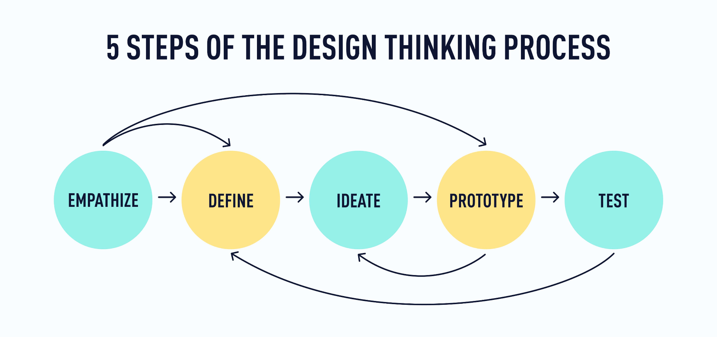

-look at DHF

-Begin thinking and working for PR2

-due at end of quarter

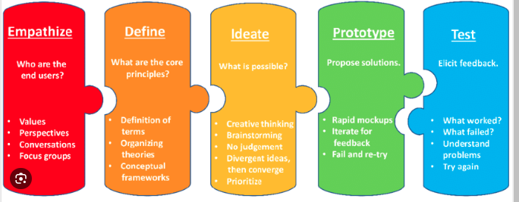

Currently in stage 3

Still need to send over another google form

Innovation Techniques:

Worst Idea

Wishing, most impossible design

Mind Map

-Can you put the lock on the hinges?

-think about hinges as a direction of your project

-potentiometer

-less complicated but more robust

-weighted door pistons idea

(you dont need to know whose been out of fridge, it’s closed regardless)

“Simpler is better”

-meet up again to discuss ideas (like discuss worst ideas)

Risk on weight door -> easy to copy and some factory in china could outproduce it

Lateral Benchmarking

-3-5 concepts means about 30-50 ideas being made (**DRAWING** or image gen AI)

-AI image generation; feed it ideas it spits out images

PR2

Must think and write about manufacturing process, especially in scale

3d printing is viable for prototypes

Engineering drawings for 3-5 concepts